EVENT MANAGEMENT
SYSTEM
ER DIAGRAM & TABLE SCHEMA
PHP and MySQL Mini Project

Prepared by | Snehashis Dalui and Ria Mondal
Programme | BCA – 5th Semester
Institution | Bhawanipur Global Campus, Kolkata
Project Supervisor | Majid Mallik
Version 1.0 | 13 October 2026

1. Entity Relationship (ER) Diagram
The diagram below illustrates the three entities and their relationships in the Event Management System.
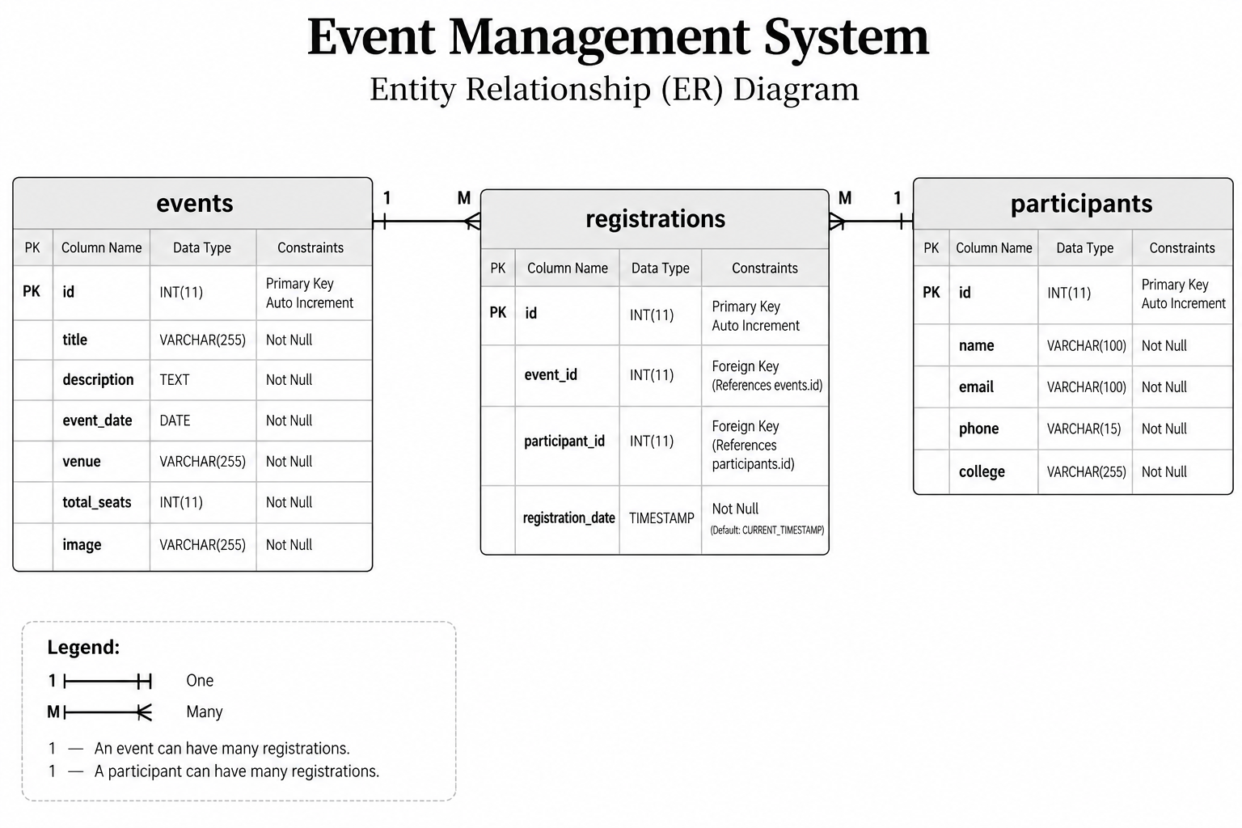
Figure 1. Entity Relationship Diagram

2. Database Table Schema
Database name: event_management

2.1 EVENTS
Stores the details of each event.
Column | Data Type | Constraints | Description
id | INT | PRIMARY KEY, AUTO_INCREMENT | Unique identifier for an event.
title | VARCHAR(150) | NOT NULL | Event title.
description | TEXT | Nullable | Description of the event.
event_date | DATE | NOT NULL | Scheduled date.
event_time | TIME | NOT NULL | Scheduled time.
venue | VARCHAR(200) | NOT NULL | Event location.
available_seats | INT | NOT NULL, DEFAULT 0 | Seats currently available.

2.2 PARTICIPANTS
Stores participant contact information.
Column | Data Type | Constraints | Description
id | INT | PRIMARY KEY, AUTO_INCREMENT | Unique identifier for a participant.
full_name | VARCHAR(100) | NOT NULL | Participant's full name.
email | VARCHAR(150) | NOT NULL | Email address.
phone | VARCHAR(15) | Nullable | Optional contact number.
created_at | TIMESTAMP | DEFAULT CURRENT_TIMESTAMP | Record creation date and time.

2.3 REGISTRATIONS
Links participants to the events for which they register.
Column | Data Type | Constraints | Description
id | INT | PRIMARY KEY, AUTO_INCREMENT | Unique identifier for a registration.
event_id | INT | NOT NULL, FOREIGN KEY | References events.id.
participant_id | INT | NOT NULL, FOREIGN KEY | References participants.id.
registration_date | TIMESTAMP | DEFAULT CURRENT_TIMESTAMP | Registration date and time.

3. Keys and Relationships
- Primary keys (PK): events.id, participants.id, and registrations.id identify rows uniquely.
- Foreign keys (FK): registrations.event_id refers to events.id; registrations.participant_id refers to participants.id.
- Relationship cardinality: One event can have many registrations; one participant can have many registrations.
- Duplicate registration prevention: A UNIQUE constraint on (event_id, participant_id) can prevent the same participant from registering for the same event more than once.
Schema note: The table schema in this document follows the project structure previously discussed. The generated ER diagram image is inserted as requested, but its field names may not fully match this schema. Please ensure the diagram and actual phpMyAdmin table definitions match before final submission.

